**A) Perform foor printing using 10 Google Hacking Commands.**

**B) Archive information from "tutorialpoint.com" atleast 2 snapshort from year 2010 for following pages**

**- Home Page**

**- Career**

**- About Us**

**- Privacy Policy**

**Home Page**

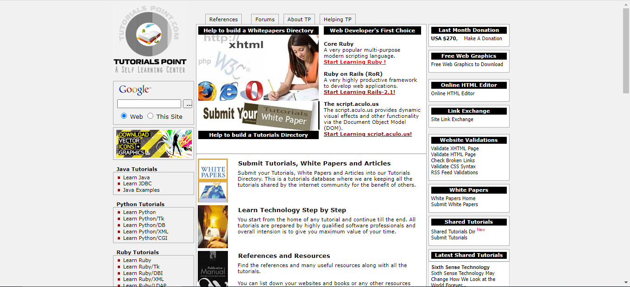

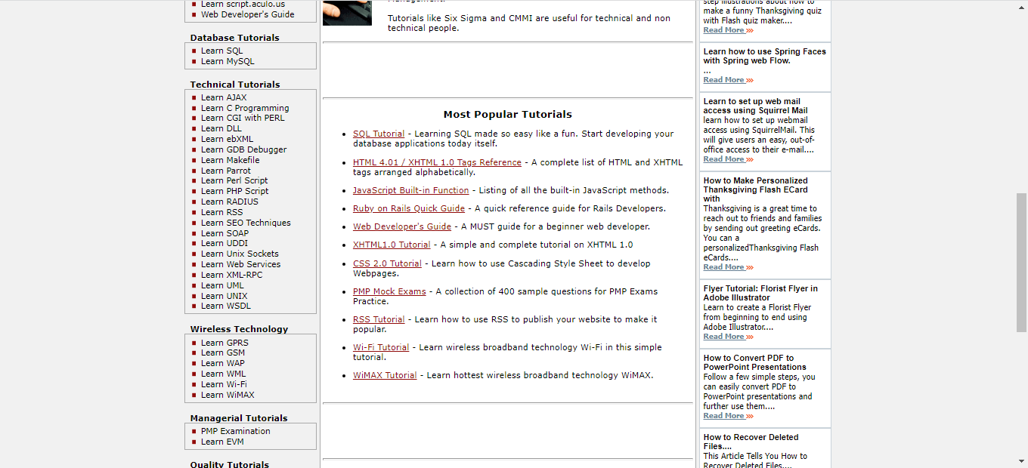

**About Us**

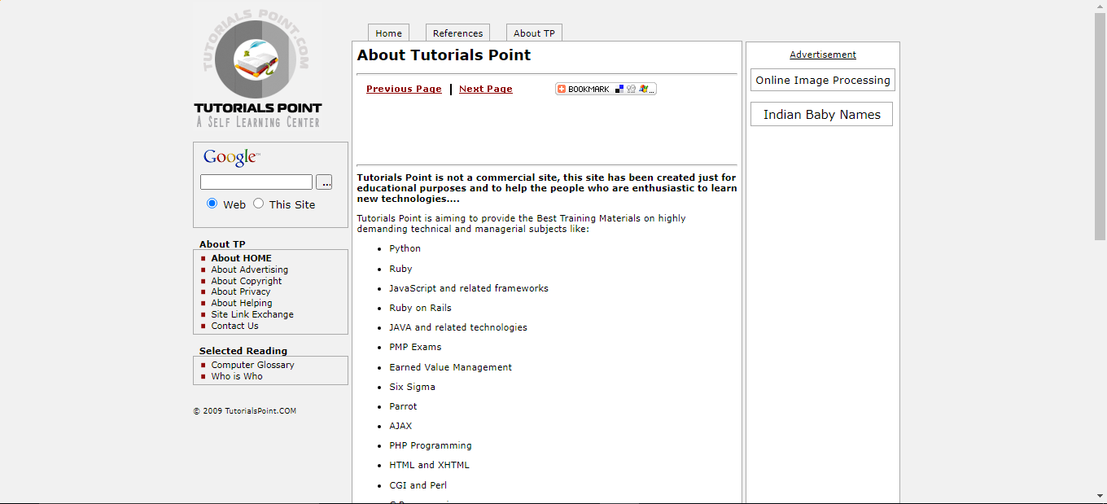

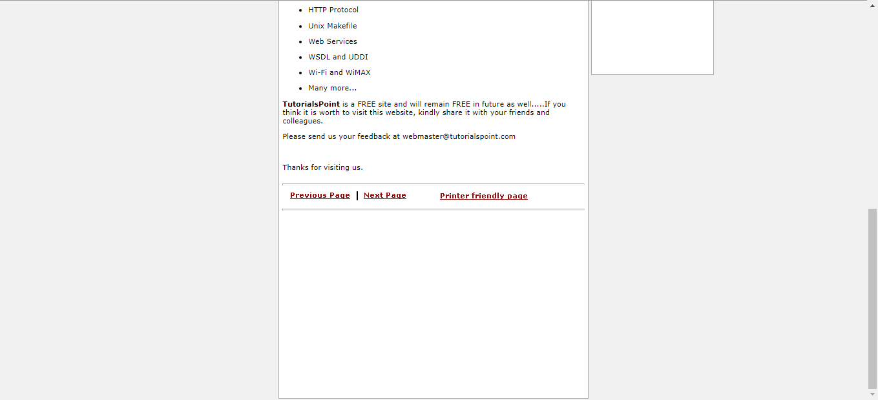

**Privacy Policy**

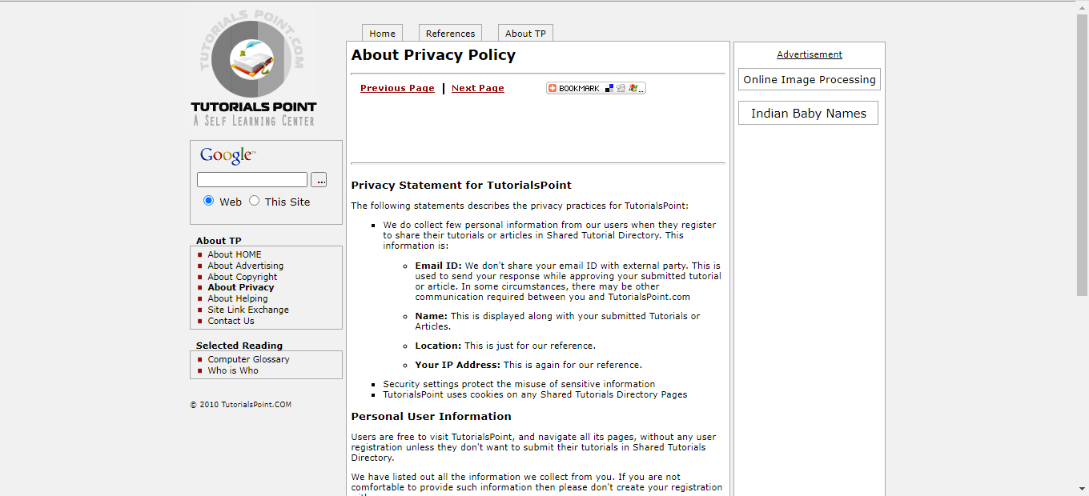

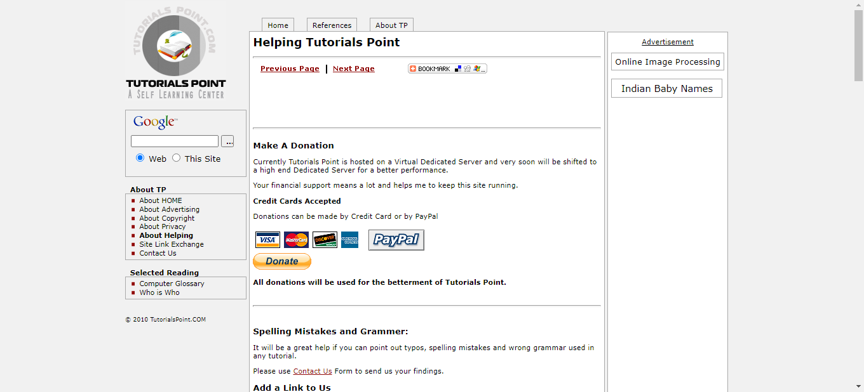

**C) How Wireshark works? Explain with steps to**

**- Capture and analyse packets**

**- Apply filters and analyse packets**